Zero Trust Network Access Using Zscaler Private Access

S.NO | NAME | COLLEGE NAME | CONTACT
1 | PAVITHRA S | SRI KRISHNA  ADITHYA COLLEGE  OF ARTS AND  SCIENCE | 23bscs238pavithras@skacas.ac.in
2 | NITHIN KANNAN M | SRI KRISHNA  ADITHYA COLLEGE  OF ARTS AND  SCIENCE | 23bscs137nithinkannanm@skacas.ac.in
3 | JEEVANANTHAM R | SRI KRISHNA  ADITHYA COLLEGE  OF ARTS AND  SCIENCE | 23bscs219jeevananthamr@skacas.ac.in
4 | PRITIKA G | SRI KRISHNA  ADITHYA COLLEGE  OF ARTS AND  SCIENCE | 23bscs241prithikag@skacas.a.in
5 | KRISHNAPRIYA K | SRI KRISHNA  ADITHYA COLLEGE  OF ARTS AND  SCIENCE | 23bscs221krishnapriyak@skacas.ac.in

Project details
Title: Zero Trust Network Access Using Zscaler Private Access

• AI-Enhanced User Protection (AIUP)

Zero Trust Network Access (ZTNA) using Zscaler Private Access is a modern security approach that ensures only authorized users can access private organizational applications and resources. Unlike traditional security models that trust users once they enter the network, ZTNA follows the principle of “Never Trust, Always Verify.” Every user and device must be authenticated and validated before being granted access to an application.
In this approach, Zscaler Private Access creates a secure connection between the user and the specific application rather than providing access to the entire network. This method significantly reduces security risks by preventing unauthorized users, compromised devices, or attackers from reaching sensitive applications.
Additionally, the system continuously verifies user identity, device health, and access permissions before allowing communication with internal applications. By combining Zero Trust principles with secure cloud-based access, Zscaler Private Access helps organizations protect their internal resources from modern cyber threats.
This solution is especially important in today’s digital environment where employees access applications from different locations and devices. With the increasing number of cyberattacks such as phishing, credential theft, and unauthorized access attempts, ZTNA with Zscaler Private Access provides a secure way to protect enterprise applications. It helps organizations prevent data breaches, reduce security vulnerabilities, and ensure that only trusted users can interact with critical systems and resources.

Abstract:
The rapid growth of cyber threats and the limitations of traditional security models, such as Virtual Private Network (VPN)-based access, have created the need for more advanced security solutions to protect organizational applications. Traditional systems often provide full network access once a user is authenticated, which can lead to serious security risks such as unauthorized access and lateral movement within the network. To overcome these challenges, this project focuses on implementing Zero Trust Network Access (ZTNA) using Zscaler Private Access to provide secure and controlled access to private applications.
This project explains how ZTNA replaces traditional network-level access with application-level, identity-based connectivity, ensuring that users can only access the specific applications they are authorized to use. In this architecture, Zscaler Private Access acts as a secure cloud-based broker between users and internal applications. Before granting access, the system verifies the user’s identity, device posture, and access policies to ensure that only trusted users are allowed to connect.
By implementing this Zero Trust model, internal applications remain hidden from the public internet, significantly reducing the attack surface and preventing unauthorized access attempts. The system can also be integrated with identity management platforms and security monitoring tools to strengthen authentication, logging, and threat detection capabilities. This enables organizations to maintain strict security policies, continuously monitor user activity, and quickly respond to potential cyber threats.
Overall, the implementation of ZTNA using Zscaler Private Access provides a scalable and efficient security framework that enhances data protection, prevents unauthorized application access, and supports secure connectivity for modern remote and mobile users in today’s digital environment.

Use Case Scenarios:
Scenario 1: Secure Remote Access for Faculty to ERP System

A faculty member working from home needs to access the university’s ERP system to upload student grades. Using Zscaler Private Access (ZPA), the user connects securely without being placed on the internal network. The system verifies identity using Multi-Factor Authentication (MFA) and checks the device security posture before granting access.

Output:

- User identity verified (Faculty Group)

- Device posture compliant (Antivirus active, OS updated)

- Secure micro-tunnel created only to ERP application

- Internal network remains completely hidden from the user

Scenario 2: External Researcher Accessing a Specific Database

An external researcher from another institution requires temporary access to a specific research database. The administrator creates a time-limited, application-specific policy using ZPA. The researcher can only access the authorized database without visibility into other systems.

Output:

- External user identity verified with temporary credentials

- Access restricted to specific application (Research Database)

- Access valid for limited duration (e.g., 7 days)

- Database server remains hidden from public internet

- Session automatically ends after access expiry

Scenario 3: Student Access to Online Examination Portal

During exams, many students access the online exam portal from different locations. ZPA ensures only authenticated students with secure devices can access the portal. It also protects against unauthorized access and cyber attacks.

Output:

- Large-scale authentication handled via cloud

- Each student connected only to exam application

- Unauthorized access attempts blocked

- Exam server IP address hidden from internet

- No access to other internal resources

Scenario 4: IT Administrator Performing Server Maintenance

An IT administrator needs to perform updates on an internal server. Instead of using VPN, they use ZPA to directly connect to the server’s management interface. All activities are monitored for security.

Output:

- Admin identity verified with MFA

- Direct secure connection to specific server only

- All actions logged for auditing

- Unauthorized access attempts blocked

- Real-time monitoring of admin activity

Stage-1

Title Of the Project: -
Zero Trust Network Access (ZTNA) using Zscaler Private Access: Securing User-to-Application Connectivity

Overview:
The project focuses on implementing a secure access model using Zero Trust Network Access (ZTNA) with Zscaler Private Access (ZPA). The goal is to provide safe, direct, and application-specific access to users without exposing the internal network. Unlike traditional VPN systems, this model ensures that users are never placed on the corporate network, reducing the risk of unauthorized access and lateral movement.

This system works based on the principle of “Never Trust, Always Verify.” Every user, device, and request is continuously authenticated and validated before granting access. Identity verification is performed using Multi-Factor Authentication (MFA), and device posture checks ensure that only secure and compliant devices can connect to applications.

The primary objective of this project is to enhance cybersecurity by limiting access strictly to required applications instead of the full network. Zscaler Private Access creates a secure micro-tunnel between the user and the specific application, ensuring that sensitive systems remain hidden from the internet and potential attackers.

Advanced security features such as identity-based access control, real-time monitoring, and policy enforcement are integrated into the system. The system continuously analyzes user behavior and access patterns to detect anomalies and prevent suspicious activities. Any unauthorized attempt is immediately blocked, ensuring strong protection against cyber threats.

Additionally, the project supports secure remote access for employees, third-party vendors, and students. Temporary and role-based access policies can be created, ensuring users only access what they need for a limited time. This minimizes security risks and improves overall control.

The system also includes logging and auditing features, which track all user activities for transparency and compliance. Encryption is applied to data both in transit and at rest to ensure data privacy and protection.

Cloud-based infrastructure ensures scalability and high availability, allowing the system to handle large numbers of users efficiently. Load balancing and distributed architecture improve performance and reliability across different locations.

Overall, this project demonstrates how ZTNA using Zscaler Private Access provides a modern, secure, and scalable solution for protecting organizational resources while enabling seamless and safe user access Once the authentication and device verification processes are completed successfully, the Zscaler

List of Vulnerability Table:
Practice Website:
S.No | Vulnerability Name | CWE - No
1 | Inclusion of Sensitive Information in  Source Code | CWE-540
2 | Improper Restriction of XML External Entity Reference | CWE-611
3 | Use of Unmaintained Third Party  Components | CWE-1104
4 | CWE-916 Use of Password Hash  With Insufficient Computational Effort | CWE-916
5 | Improper Neutralization of HTTP Headers for Scripting Syntax | CWE-644
6 | Reliance on Untrusted Inputs in a Security Decision | CWE-807
7 | Improper Verification of Source of a Communication Channel | CWE-940
8 | Inclusion of Functionality from Untrusted Control Sphere | CWE-829

9 | Information Loss of Omission | CWE-221
10 | Improper Check for Unusual or Exceptional Conditions | CWE-754

REPORTS:

1) Vulnerability Name: Inclusion of Sensitive Information in Source Code CWE/CVE: CWE-540 OWASP/SANS Category:

Description:
CWE-540 is a security weakness where sensitive information such as passwords, API keys, encryption keys, or database credentials is stored directly in the source code. If the source code is accessed by unauthorized users or shared publicly, attackers can easily obtain this confidential information and misuse it to access systems or data.

Business Impact:

- Attackers may gain unauthorized access to applications or databases.

- It can lead to data breaches and financial loss.

- The organization’s reputation and customer trust may be affected.

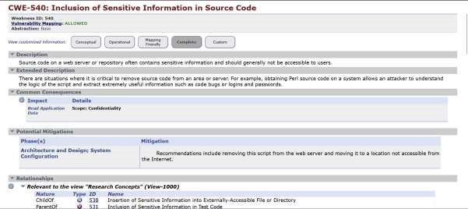

2) Vulnerability Name: Improper Restriction of XML External Entity Reference
CWE/CVE: CWE-611
OWASP/SANS Category:

Description
Improper Restriction of XML External Entity Reference (XXE) occurs when an application processes XML input without properly restricting external entity references. Attackers can exploit this vulnerability by sending malicious XML data that forces the server to access local files, internal systems, or external resources. This may lead to unauthorized access to sensitive information or allow attackers to perform server-side request forgery (SSRF). Business Impact
This vulnerability can expose confidential data such as system files or internal network information. Attackers may use this data to gain further access to the system or disrupt services. For organizations, it can result in data breaches, operational risks, financial loss, and damage to reputation.

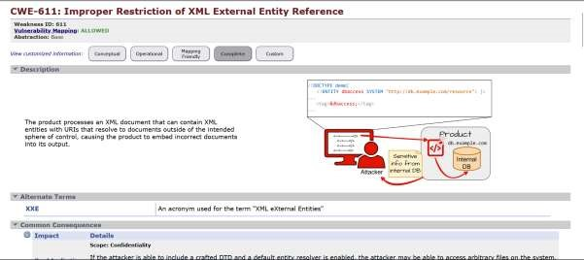

3) Vulnerability Name:Use of Unmaintained Third Party Components

CWE/CVE: CWE-1104 OWASP/SANS Category:

Description
This vulnerability occurs when an application uses third-party libraries or components that are no longer maintained or updated by their developers. These components may contain known security flaws, bugs, or compatibility issues that are not fixed because the software is outdated. Attackers can exploit these weaknesses to compromise the application or gain unauthorized access.

Business Impact
Using unmaintained components can expose the system to security risks and vulnerabilities. It may lead to data breaches, system compromise, or service disruptions. For organizations, this can cause financial losses, compliance issues, and damage to reputation if sensitive data or services are affected.

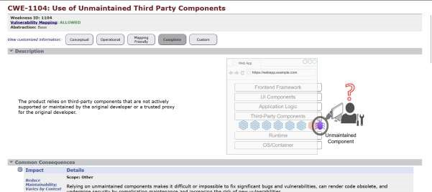

4) Vulnerability Name: Use of Password Hash With Insufficient Computational Effort
CWE/CVE: CWE-916
OWASP/SANS Category:

Description
This vulnerability occurs when an application stores passwords using hashing algorithms that require very low computational effort, such as weak or outdated hashing methods. These hashes can be easily cracked by attackers using brute-force or dictionary attacks. As a result, attackers may recover the original passwords from the stored hashes.

Business Impact
If attackers successfully crack password hashes, they can gain unauthorized access to user accounts and sensitive systems. This may lead to data breaches, account compromise, and misuse of confidential information. For organizations, it can result in financial losses, security incidents, and damage to customer trust and reputation.

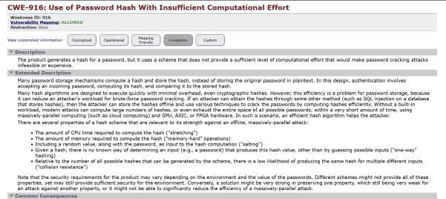

5) Vulnerability Name: Misinterpretation of Output
CWE/CVE: CWE-115
OWASP/SANS Category: A05:2025-Injection

Description
Misinterpretation of Output (CWE-115) occurs when an application does not properly handle or validate output data before it is interpreted by another system component. As a result, malicious input may be treated as executable commands or code. This weakness is related to Injection vulnerabilities (OWASP A05:2025), where attackers manipulate data so that it is executed or processed in unintended ways.
Business Impact
If exploited, attackers can inject malicious commands or code into the system, potentially leading to unauthorized data access, system compromise, or manipulation of application behavior. This may result in data breaches, service disruption, and damage to the organization’s reputation and security posture.

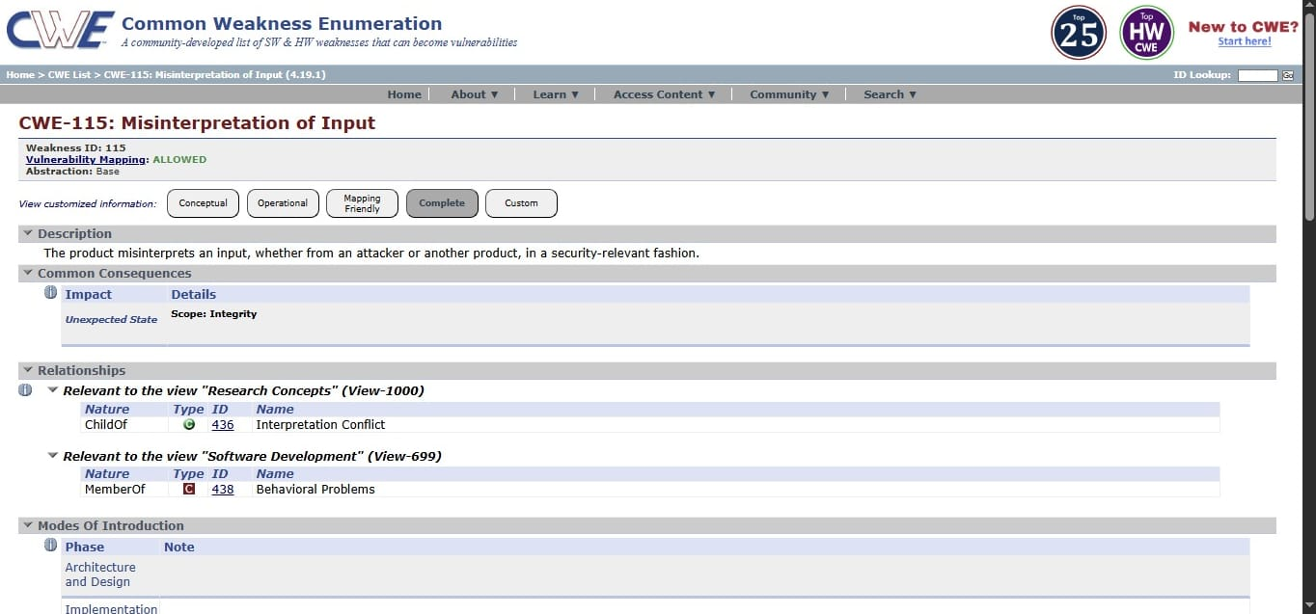

6) Vulnerability Name: Reliance on Untrusted Input in a Security Decision
CWE/CVE: CWE-807
OWASP/SANS Category

Description
This vulnerability occurs when an application does not properly sanitize or validate HTTP header values before processing them. Attackers can inject malicious scripting code into HTTP headers, which may be executed by the web application or the user’s browser. This can lead to cross-site scripting (XSS) attacks or manipulation of application responses.

Business Impact
Exploitation of this vulnerability may allow attackers to steal sensitive information such as session cookies, user credentials, or personal data. It can also lead to unauthorized actions on behalf of users. For businesses, this may result in security breaches, loss of user trust, and potential legal or compliance issues.

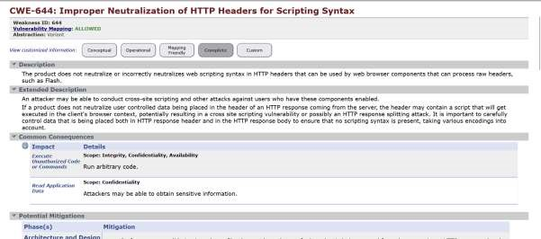

7)Vulnerability Name: Improper Verification of Source of a Communication Channel
CWE/CVC: CWE-940
OWASP/SANS Category

Description
This vulnerability occurs when an application makes security-related decisions based on input received from untrusted sources, such as user input, client-side data, or external systems. If the application does not properly validate or verify this input, attackers may manipulate the data to bypass security controls or gain unauthorized access.

Business Impact
Exploiting this vulnerability can allow attackers to bypass authentication, access restricted resources, or perform unauthorized actions within the system. This may lead to data breaches, system misuse, and loss of sensitive information. For organizations, it can result in financial losses, operational risks, and damage to reputation

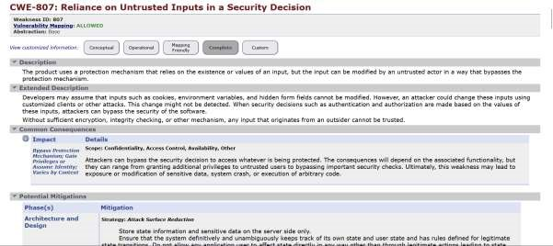

8)Vulnerability Name: Inclusion of Functionality from Untrusted Control Sphere
CWE/CVE: CWE-829
OWASP/SANS Category:

Description
This vulnerability occurs when an application fails to properly verify the source of a communication channel before accepting or processing data. If the system does not authenticate the sender or validate the communication source, attackers may impersonate trusted entities and send malicious or unauthorized data to the application.

Business Impact
Exploitation of this vulnerability can allow attackers to perform unauthorized actions, intercept sensitive data, or manipulate communications between systems. This may lead to security breaches, data compromise, and service disruption. For organizations, it can cause financial loss, operational impact, and damage to reputation.

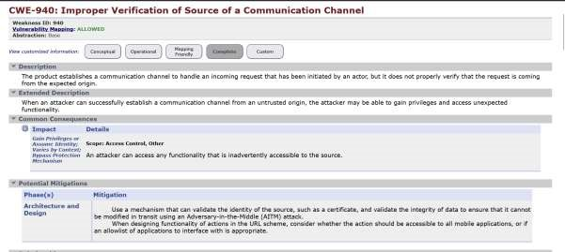

9) Vulnerability Name: Information Loss of Omission
CWE/CVE: CWE-221
OWASP/SANS Category:

Description
This vulnerability occurs when important information is omitted or not properly included during data processing, storage, or transmission. Missing critical data elements can lead to incorrect system behavior, inaccurate records, or incomplete security checks. Attackers may exploit such omissions to manipulate system operations or bypass controls.

Business Impact
Information loss due to omission can result in inaccurate decision-making, data integrity issues, and security weaknesses. It may affect system reliability and cause operational problems. For organizations, this can lead to financial loss, compliance issues, and reduced trust in the system.

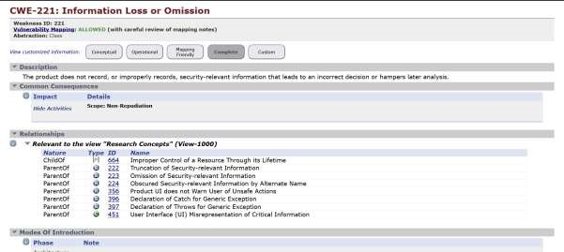

10) Vulnerability Name: Check for unusual or Exceptional Conditions
CWE/CVE: CWE-754 OWASP/SANS Category:

Description
This vulnerability occurs when an application does not properly handle unusual or unexpected conditions such as invalid inputs, system errors, or unexpected states. Without proper checks and error handling, the system may behave unpredictably or expose sensitive information. Attackers may exploit these situations to bypass security controls or cause system failures.

Business Impact
Failure to handle exceptional conditions can lead to system crashes, data corruption, or exposure of sensitive information. It may also allow attackers to exploit weaknesses in the system. For organizations, this can result in service disruptions, security risks, and potential financial or reputational damage.

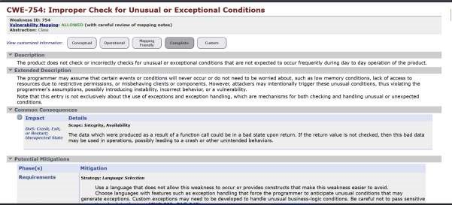

Stage 2

Overview :-

Nessus is a vulnerability scanner developed by Tenable, Inc. It is a remote scanner, meaning that it does not need to be installed on the target host to scan it. Nessus works by sending a variety of probes to the target host in order to identify vulnerabilities. These probes can include network traffic, operating system commands, and application requests.

Nessus uses a plugin-based architecture. Plugins are small pieces of code that are designed to identify specific vulnerabilities. There are over 1200 plugins available for Nessus, covering a wide range of vulnerabilities in operating systems, applications, and network devices.

When Nessus scans a host, it first uses a discovery plugin to identify the operating system and services running on the host. Once the host has been discovered, Nessus runs a series of plugins to test for vulnerabilities. For each vulnerability that Nessus finds, it provides a detailed report that includes the severity of the vulnerability, the steps to reproduce the vulnerability, and the steps to remediate the vulnerability. Nessus can be used to scan a variety of targets, including single hosts, networks, and web applications. It can also be used to scan specific ports and services. Nessus can be configured to run scans on a schedule or manually.

Here is a step-by-step explanation of how Nessus works:

- Nessus connects to the target host using a variety of protocols, including TCP, UDP, and ICMP.
- Nessus sends a series of probes to the target host in order to identify its operating system and services.
- Nessus runs a series of plugins to test for vulnerabilities.
- Nessus generates a report that includes the severity of each vulnerability, the steps to reproduce the vulnerability, and the steps to remediate the vulnerability.

Nessus is a valuable tool for security professionals who need to identify and remediate vulnerabilities in their networks. It is easy to use and provides comprehensive reports that can be used to prioritise remediation efforts.

Here are some of the benefits of using Nessus:

- Comprehensive vulnerability coverage: Nessus has over 1200 plugins available, covering a wide range of vulnerabilities in operating systems, applications, and network devices.
- Easy to use: Nessus has a user-friendly interface that makes it easy to configure and run scans.
- Comprehensive reporting: Nessus provides detailed reports that include the severity of each vulnerability,the steps to reproduce the vulnerability, and the steps to remediate the vulnerability.
- Scalability: Nessus can be used to scan a variety of targets, including single hosts, networks, and web applications.
- Flexibility: Nessus can be configured to run scans on a schedule or manually.

Nessus is a powerful tool that can be used to improve the security of any network. It is a valuable asset for any security professional.

Target website :- http://testfire.net/

Target ip address:- 65.61.137.117

List of vulnerability:-

s.no | Vulnerability name | Severity | plugins
1 | TLS Version 1.0 Protocol  Detection | MEDIUM | 104743
2 | TLS Version 1.1 Protocol  Deprecated | MEDIUM | 157288
3 | SSL/TLS Diffie-Hellman Modulus  <= 1024 Bits (Logjam) | LOW | 83875
4 | ICMP Timestamp Request Remote  Date Disclosure | INFO | 10114
5 | Additional DNS Hostnames | INFO | 46180
6 | Apache Tomcat Detection | INFO | 39446
7 | Common Platform Enumeration  (CPE) | INFO | 45590
8 | Device Type | INFO | 54615
9 | HSTS Missing From HTTPS  Server | INFO | 84502
10 | HTTP Server Type and Version | INFO | 10107

REPORT: -

1) Vulnerability Name: - 104743 - TLS Version 1.0 Protocol Detection
Severity: - MEDIUM
Plugin: - 104743

Port: - 443
Description: - The remote service accepts connections encrypted using TLS 1.0. TLS 1.0 has a number of cryptographic design flaws. Modern implementations of TLS 1.0 mitigate these problems, but newer versions of TLS like 1.2 and 1.3 are designed against these flaws and should be used whenever possible.
As of March 31, 2020, Endpoints that aren’t enabled for TLS 1.2 and higher will no longer function properly with major web browsers and major vendors.
PCI DSS v3.2 requires that TLS 1.0 be disabled entirely by June 30, 2018, except for POS POI terminals (and the SSL/TLS termination points to which they connect) that can be verified as not being susceptible to any known exploits.
Solution: - Enable support for TLS 1.2 and 1.3, and disable support for TLS 1.0.
Business Impact: -Continued use of TLS 1.0's encryption, known for its inherent cryptographic flaws, exposes the organization to heightened security risks, increasing the likelihood of data breaches and cyberattacks. This vulnerability jeopardizes compliance with industry standards, specifically PCI DSS v3.2, which mandates the complete cessation of TLS 1.0 use. Non- compliance risks regulatory penalties and erodes customer trust. Moreover, endpoints that lack support for TLS 1.2 and higher will experience impaired functionality with major web browsers and vendors, potentially leading to lost business opportunities and damage to the organization's reputation. Addressing this vulnerability is imperative to mitigate these multifaceted risks and maintain a secure and trustworthy online presence.

2) Vulnerability Name: - 157288 - TLS Version 1.1 Protocol
Deprecated

Severity: - MEDIUM
Plugin: - 157288

Port: - 443
Description: - The remote service accepts connections encrypted using TLS 1.1. TLS 1.1 lacks support for current and recommended cipher suites. Ciphers that support encryption before MAC computation, and authenticated encryption modes such as GCM cannot be used with TLS 1.1 As of March 31, 2020, Endpoints that are not enabled for TLS 1.2 and higher will no longer function properly with major web browsers and major vendors.
Solution: - Enable support for TLS 1.2 and/or 1.3, and disable support for TLS 1.1. Business Impact: -The continued use of TLS 1.1 with its lack of support for modern cipher suites and advanced encryption methods jeopardizes the organization's security posture, increasing vulnerability to cyber threats and potential data breaches. Additionally, endpoints not upgraded to support TLS 1.2 and higher will encounter compatibility issues with major web browsers and vendors, impacting user experience and potentially leading to missed business opportunities. Swift remediation of this vulnerability is essential to mitigate security risks and ensure seamless interactions with web browsers and vendors, preserving the organization's reputation and operational efficiency.

3) Vulnerability Name:- 83875 SSL/TLS Diffie-Hellman Modulus <= 1024 Bits
(Logjam)

Severity: - LOW
Plugin: - 83875

Port: - 443
Description: - The remote host allows SSL/TLS connections with one or more Diffie-Hellman moduli less than or equal to 1024 bits. Through cryptanalysis, a third party may be able to find the shared secret in a short amount of time (depending on modulus size and attacker resources). This may allow an attacker to recover the plaintext or potentially violate the integrity of connections.
Solution: - Reconfigure the service to use a unique Diffie-Hellman moduli of 2048 bits or greater.
Business Impact: - Allowing SSL/TLS connections with weak Diffie-Hellman moduli raises security concerns. An attacker with sufficient resources and computing power could compromise the shared secret relatively quickly, potentially leading to the decryption of sensitive data or the violation of connection integrity. While the severity is low, the risk of data breaches and integrity compromise should not be underestimated, and it is essential to address this vulnerability to maintain data security and user trust.

4) Vulnerability Name: - 10114 ICMP Timestamp Request Remote Date
Disclosure
Severity: - INFO
Plugin: - 10114

Port: - 0
Description: - The remote host answers to an ICMP timestamp request. This allows an attacker to know the date that is set on the targeted machine, which may assist an unauthenticated, remote attacker in defeating time-based authentication protocols.
Timestamps returned from machines running Windows Vista / 7 / 2008 / 2008 R2 are deliberately incorrect, but usually within 1000 seconds of the actual system time.
Solution: - Filter out the ICMP timestamp requests (13), and the outgoing ICMP timestamp replies (14).
Business Impact: -This does not pose an immediate threat to business operations or data security. This vulnerability allows external parties to request the system's date and time information remotely. While it does not present a significant risk, it could potentially be used by attackers for reconnaissance purposes. Therefore, it is advisable to address this vulnerability as part of a broader security posture to reduce the risk of unauthorized data gathering and protect against potential future threats.
46180 Additional DNS
5) Vulnerability Name: -Hostnames Severity: - INFO
Plugin: - 46180

Port: - 0
Description: - Hostnames different from the current hostname have been collected by miscellaneous plugins. Nessus has generated a list of hostnames that point to the remote host.
Note that these are only the alternate hostnames for hosts discovered on a web server.
Different web servers may be hosted on name-based virtual hosts.
Solution: - If you want to test them, re-scan using the special vhost syntax, such as :
www.example.com [192.0.32.10]
Business Impact: -This does not pose an immediate threat to business operations or data security. It indicates the discovery of hostnames that are associated with the remote host, particularly in cases of web servers utilizing name-based virtual hosts. While not a security risk on its own, it could be useful for understanding the server's configuration and infrastructure. Organizations should consider this information as part of their network documentation but do not need to take immediate action to mitigate it as a security threat.

6) Vulnerability Name: -39446 Apache Tomcat
Detection Severity: - INFO
Plugin: - 39446

Port: - 80
Description: -Nessus was able to detect a remote Apache Tomcat web server.

Solution: - n/a
Business Impact: -Is an informational finding that identifies the presence of a remote Apache Tomcat web server. While this information itself does not indicate a security threat or impact on business operations, it can be useful for network administrators and security professionals to be aware of the technologies in use on their network. Understanding the presence of an Apache Tomcat server can be valuable for maintaining and securing web applications, but it does not require immediate action to mitigate a security risk.

7) Vulnerability Name: -45590-Common Platform Enumeration
(CPE)
Severity: - INFO
Plugin: - 45590

Port: - 0
Description: - By using information obtained from a Nessus scan, this plugin reports CPE
(Common Platform Enumeration) matches for various hardware and software products found on a host.
Note that if an official CPE is not available for the product, this plugin computes the best possible CPE based on the information available from the scan.

Solution: - n/a
Business Impact: - This provides insights into hardware and software products identified on a host through a Nessus scan. It reports CPE matches, which are standardized identifiers for these products. This information is valuable for asset management and inventory purposes. While it doesn't signify a security threat, it aids administrators in understanding the components within their network, contributing to effective resource management and facilitating future system maintenance.

8)Vulnerability Name : 45590 – Common Plateform Enumeration(CPE)
Severity: - INFO Plugin: - 54615

Port: - 0
Description: - Based on the remote operating system, it is possible to determine what the remote system type is (eg: a printer, router, general-purpose computer, etc).

Solution: -
Business Impact: - It allows for the identification of the remote system type, such as a printer, router, or general-purpose computer, based on the remote operating system. While this doesn't pose a direct security threat, it offers valuable insights for network administrators to better understand and classify the devices in their network. This information aids in network management, optimization, and ensures that the right security measures are in place for each device type.

9)Vulnerability Name: - 84502 - HSTS Missing From HTTPS

Server Severity: - INFO
Plugin: - 84502

Port: - 443
Description: -The remote HTTPS server is not enforcing HTTP Strict Transport Security (HSTS). HSTS is an optional response header that can be configured on the server to instruct the browser to only communicate via HTTPS. The lack of HSTS allows downgrade attacks, SSL- stripping man-in-the-middle attacks, and weakens cookie-hijacking protections.
Solution: - Configure the remote web server to use HSTS.
Business Impact: -Indicates that the remote HTTPS server does not enforce HTTP Strict Transport Security (HSTS). HSTS is a crucial security feature that, when configured on the server, instructs web browsers to communicate exclusively via HTTPS, enhancing security. The absence of HSTS potentially exposes the server to downgrade attacks, SSL-stripping man-in-the- middle attacks, and weakens protections against cookie hijacking, posing risks to data confidentiality and user security. Enabling HSTS is essential to ensure a higher level of protection for data transmitted between clients and the server.

10)Vulnerability Name: - 10107 - HTTP Server Type and
Version

Severity: - INFO
Plugin: - 10107

Port: - 443
Description: - This plugin attempts to determine the type and the version of the remote web server.

Solution: - N/A
Business Impact: -This relates to the identification of the remote web server's type and version. While this issue doesn't pose an immediate security threat, it can provide valuable information to potential attackers about the server's software stack. Knowledge of the server type and version may aid attackers in exploiting known vulnerabilities specific to that software, making it important to restrict such information from being easily accessible to enhance the server's overall security posture.

Stage – 3
Report: -

Title: - Implementing Zero Trust Network Access (ZTNA) with Zscaler: Preventing Unauthorized Access.”

Zero Trust Network Access (ZTNA)
Zero Trust Network Access (ZTNA) is a security model that provides safe remote access to an organization’s internal applications and data. It works based on strict access control policies. Unlike traditional VPNs, which allow users to access the entire network, ZTNA follows the principle “never trust, always verify.”
In this approach, users are allowed to access only the specific applications they need. Before giving access, the system verifies the user’s identity and checks whether the device is secure. This helps prevent unauthorized users from accessing sensitive applications.
ZTNA is an important part of modern cybersecurity. It hides internal applications from the internet and creates secure encrypted connections between users and applications. This reduces security risks and prevents common cyber attacks such as unauthorized access and lateral movement inside the network.

• The ZTNA Access Cycle
The ZTNA cycle is a continuous process of verifying identity, establishing secure connections, and enforcing policy for every access request. It typically consists of the following steps:
- User Request: A user, from any location (office, home, coffee shop), requests access to a specific internal application (e.g., an HR portal, a finance server, or an internal code repository).

- Identity and Device Verification: Before any connection is established, the ZTNA solution verifies who the user is (via multi-factor authentication, or MFA) and checks the security posture of their device. This includes ensuring the device has up-to-date antivirus, a healthy firewall, and is not compromised.
- Policy Enforcement: The ZTNA solution checks the access policy. Does this specific user, with this specific device, have permission to access the requested application at this specific time?
- Establish Secure Connection: If the policy allows access, the ZTNA solution creates a highly secure, encrypted micro-tunnel between the user's device and the target application.
Crucially, the user never gains access to the underlying network, only to the application itself.
- Continuous Monitoring: The ZTNA solution continues to monitor the connection for anomalies. If the user's behavior becomes suspicious or their device posture changes, the connection can be terminated in real-time.
- Logging and Analytics: All access attempts, successful and failed, are logged and
- analyzed. This data is used for auditing, threat hunting, and refining access policies.

Zscaler (Zscaler Internet Access / Zscaler Private Access)
Zscaler is a cloud-based security platform that helps organizations securely access applications and protect their network. It delivers security services from the cloud, so there is no need for traditional hardware such as VPN devices.
For Zero Trust Network Access (ZTNA), Zscaler provides Zscaler Private Access (ZPA). This service allows users to securely access private applications without giving them full access to the internal network. Access is provided based on user identity, device security, and defined access policies, which helps prevent unauthorized application access.
Zscaler works on a simple concept: the internal application is connected to the Zscaler cloud, and authorized users securely access it through the cloud. To make access decisions and improve security, Zscaler collects information from different sources such as:
- Identity Providers (IdP) – Services like Azure AD or Ping Identity are used to verify the user’s identity before allowing access.
- Device Security Tools – Tools such as CrowdStrike or Microsoft Defender check whether the user’s device is secure and meets security requirements.
- Business Applications – These include internal applications like web portals, file servers, and other systems hosted in data centers or cloud platforms.
- Zscaler App Connectors – These are small software components installed in the data center or cloud that create secure connections to the Zscaler cloud and hide internal servers from the public internet.

Policy Enforcement in Zscaler
Using the collected security data, Zscaler enforces strict access policies to protect applications and prevent unauthorized access in a Zero Trust Network Access (ZTNA) environment.
The main policy controls include:
- Identity-Based Access – Access policies are based on the user’s identity or group (such as students, faculty, or staff) instead of relying only on IP addresses.
- Application Segmentation – Users are allowed to access only the specific applications they need, rather than gaining access to the entire internal network or subnet.
- Least Privilege Access – Users are given only the minimum level of access required to perform their tasks, which helps reduce security risks and prevents unauthorized activities.

The Zscaler ZTNA Cycle
The Zscaler Private Access ZTNA cycle shows how Zscaler applies the principles of Zero Trust Network Access (ZTNA) to provide secure access to internal applications through the cloud. The main steps are:
- User Login and Authentication – A user tries to access an internal application. The user is redirected to the organization’s Identity Provider for authentication and Multi-Factor Authentication (MFA).
- Device Posture Check – Zscaler checks the security status of the user’s device using integrated security tools to ensure it follows the organization’s security policies.
- Policy Verification – The Zscaler cloud checks the access request against security policies to confirm whether the user, device, and other factors such as location and time are authorized.
- Secure Micro-Tunnel Creation – If the request is approved, Zscaler creates a secure encrypted connection between the user’s device and the specific application using the Zscaler Client Connector and App Connector.
- Traffic Inspection – Zscaler can optionally inspect the traffic for security threats, data loss prevention (DLP), or malware detection.
- Logging and Analytics – All user activities and access attempts are recorded in the Zscaler cloud portal for monitoring, reporting, and security analysis.

MISP Integration
Malware Information Sharing Platform (MISP) can be integrated with Zscaler to improve security in a Zero Trust Network Access (ZTNA) environment.
- Threat Intelligence Feed – MISP shares information about malicious IPs, domains, and URLs with Zscaler.
- Proactive Blocking – If a user tries to access a malicious website, Zscaler Internet Access (ZIA) can automatically block it.
- Better Visibility – Security teams can compare MISP data with Zscaler logs to identify suspicious activities.

College Network Infrastructure
A college network usually includes routers, switches, wireless access points, firewalls, IDS, and internal application servers such as student portals and research systems.
Currently, many colleges use VPN for remote access. However, VPN provides broad network access, which can create security risks if a device is compromised.

Deploying ZTNA Using Zscaler
To deploy Zscaler Private Access (ZPA) in a college:
- Identify internal applications that need secure access.
- Create user groups such as students, faculty, and staff.
- Configure Zscaler policies to allow users to access only the applications they need.

Plan for Deploying ZTNA using Zscaler
To implement Zscaler Private Access (ZPA) in a college network using Zero Trust Network Access (ZTNA), the plan includes the following steps:
- Application Discovery – Identify all internal applications such as ERP systems, library portals, research servers, and file-sharing services that are currently accessed through VPN.
- User Segmentation – Divide users into groups like students, faculty, IT staff, and external collaborators, and determine which applications each group needs.
- Deploy Zscaler App Connectors – Install App Connectors in the college data center so that internal applications can securely connect to the Zscaler cloud while remaining hidden from the public internet.
- Integrate Identity Provider – Connect Zscaler with the organization’s identity provider such as Microsoft Azure AD to use existing login credentials and Multi-Factor Authentication.
- Configure Access Policies – Create access rules in the Zscaler portal to control which users can access specific applications.
- Deploy Zscaler Client Connector – Install the client connector on user devices so that traffic to private applications is securely routed through Zscaler.

Threat Intelligence in Zscaler ZTNA
In Zscaler and Zero Trust Network Access (ZTNA), threat intelligence helps identify who is accessing applications, from where, and whether the activity is risky. It provides better security by analyzing user behavior and access patterns.

Sources of Threat Intelligence
1. Zscaler Cloud Logs – Provide real-time information about user access, including which applications are accessed, device details, and location.

2. External Threat Feeds – Platforms like Malware Information Sharing Platform
(MISP) provide information about malware, phishing attacks, and malicious servers.
3. Identity Provider Logs – Login records from identity providers help detect unusual login attempts, such as a user logging in from different locations within a short time.

Uses of Threat Intelligence
- Adaptive Access Control – If a login attempt comes from a risky location, Zscaler can require additional verification or block the access request.
- Detecting Compromised Accounts – Security teams can analyze Zscaler logs to identify unusual behavior, such as users accessing applications they normally do not use.
- Blocking Malicious Traffic – Zscaler Internet Access (ZIA) can block connections to known malicious websites and protect users from cyber threats.

Incident Response in ZTNA (Using Zscaler)
Incident response in a Zero Trust Network Access (ZTNA) environment using Zscaler is faster and more controlled because access is limited to specific applications.
- Detection – The security team detects suspicious activity using Zscaler logs, such as unusual data downloads or login behavior.
- Containment – The user or device can be quickly blocked in the Zscaler portal to stop unauthorized access.
- Eradication – The infected device is scanned and cleaned to remove malware.
- Recovery – After fixing the issue and resetting credentials, access is safely restored.
- Review – Security teams analyze logs and update policies to prevent similar attacks in the future.

Benefits of ZTNA Incident Response
Using Zscaler in a Zero Trust Network Access (ZTNA) environment provides several benefits:
- Fast Containment – Security teams can quickly block users or devices through the cloud dashboard.
- No Lateral Movement – Attackers cannot move to other systems because access is limited to specific applications.
- Better Investigation – Zscaler provides detailed logs of all user activities for easier analysis.
- Compliance Support – Helps organizations protect sensitive data and meet security regulations.

Understanding the Tool – Zscaler ZPA
Zscaler Private Access (ZPA) is a cloud service that follows the ZTNA principle of connecting users directly to applications instead of the entire network.
Key features include:
- Application-Based Access – Access policies are defined for specific applications rather than the entire network.
- Hidden Network – Internal servers remain hidden from the internet, reducing attack risks.
- Secure Access – Applications become visible only after proper authentication and verification.
- Better User Experience – Users can access applications easily without complex VPN connections.
- Scalability – Being cloud-based, ZPA can support many users without needing additional hardware.

Conclusion
Stage 1:
In the first stage, the concept of Zero Trust Network Access (ZTNA) was introduced. It explains the importance of verifying user identity and device security before allowing access to internal applications.
Stage 2:
The second stage focused on understanding how Zscaler implements ZTNA using Zscaler Private Access (ZPA). It demonstrated how users are connected directly to applications through secure encrypted connections instead of giving full network access like traditional VPNs.
Stage 3:
The final stage explained the deployment and benefits of ZTNA with Zscaler in an organization. It showed how identity-based access, application segmentation, and continuous monitoring help prevent unauthorized application access and improve overall cybersecurity.

Considering the future scope,
Stage 1 illuminated the evolving landscape of web application testing. With advancements in AI, there is a promising avenue for more sophisticated testing methodologies, ensuring even higher levels of security for web applications.

Stage 2 highlighted the future trajectory of the testing process, indicating a shift towards more automation and integration of AI-driven tools. This evolution promises quicker, more accurate vulnerability assessments, enhancing overall cybersecurity postures.

Stage 3 illuminated the future potential of Zero Trust Network Access (ZTNA) and Zscaler technologies. With AI integration and machine learning, these systems are poised to become more intelligent and adaptive, enabling real-time risk assessment based on user behavior and device posture. Enhanced automation in policy enforcement, predictive analytics for threat detection, and improved scalability are anticipated, empowering organizations to stay ahead of sophisticated cyber threats in an increasingly distributed world.

In essence, the project not only provided a deep understanding of the current state zero trust using ZSCALER but also offered a glimpse into the exciting future of cybersecurity. Embracing these advancements will be crucial for organisations aiming to fortify their digital landscapes in the face of ever-evolving cyber threats.

Future Scope: -

Future of web application testing

The future of WAT is bright, as web applications become increasingly complex and sophisticated. Organizations are increasingly reliant on web applications to conduct business, and they need to be confident that their web applications are secure and reliable.

Here are some of the key trends that are expected to shape the future of WAT:

- Increased focus on security: Security is a top priority for all organizations, and WAT is essential for identifying and mitigating security vulnerabilities. In the future, we can expect to see even more emphasis on security testing, as web applications become increasingly targeted by cyberattacks.
- Rise of artificial intelligence (AI) and machine learning (ML): AI and ML are already being used in WAT, and their role is expected to grow in the future. AI and ML can be used to automate repetitive tasks, such as test case generation and execution. They can also be used to identify complex patterns and anomalies that may be difficult to detect with traditional testing methods.
- Shift to cloud-based testing: More and more organizations are moving their web applications to the cloud. This trend is driving the growth of cloud-based WAT platforms. Cloud-based testing platforms offer a number of advantages, such as scalability, flexibility, and cost-effectiveness.
- Increased focus on user experience (UX) testing: UX testing is essential for ensuring that web applications are easy to use and meet the needs of users. In the future, we can expect to see more focus on UX testing, as organizations increasingly recognize the importance of providing a positive user experience.

Future scope of the testing process

The future scope of the testing process is bright, as software becomes increasingly complex and sophisticated. Organisations are increasingly reliant on software to conduct business, and they need to be confident that their software is high-quality and reliable

Here are some of the key trends that are expected to shape the future of the testing process:

- Increased focus on continuous testing: Continuous testing is a methodology that involves testing software throughout the SDLC, from development to deployment. This helps to identify defects early and prevent them from causing problems later in the development process.
- Rise of AI and ML: AI and ML are already being used in the testing process, and their role is expected to grow in the future. AI and ML can be used to automate repetitive tasks, such as test case generation and execution. They can also be used to identify complex patterns and anomalies that may be difficult to detect with traditional testing methods.
- Shift to cloud-based testing: Cloud-based testing platforms offer a number of advantages, such as scalability, flexibility, and cost-effectiveness. This is driving the growth of cloud-based testing platforms.
- Increased focus on testing automation: Testing automation is the use of software to execute test cases without human intervention. Testing automation can help to save time and resources, and it can also help to improve the quality and efficiency of testing.
Future
scope of SOC/SEIM:-

The future scope of Zero Trust Network Access (ZTNA) and the broader Zero Trust framework is poised for significant evolution, driven by emerging technologies and changing threat landscapes:
  - AI-Driven Zero Trust (AI-ZTA): Future Zero Trust implementations will leverage advanced AI and deep learning to move beyond static policies. Systems will continuously learn user behavior, predict anomalous activities before they occur, and dynamically adjust access privileges in real-time based on contextual risk, creating a truly "adaptive" security posture.

  - Integration with Edge Computing and IoT: As organizations deploy more IoT devices and edge computing nodes, Zero Trust principles will extend to these resource-constrained environments. Expect the development of lightweight Zero Trust agents and protocols that can authenticate and secure machine-to-machine (M2M) communication at the edge, preventing large-scale botnet attacks.

  - Identity-Centric Everything: The future will see identity become the ultimate security perimeter. Zero Trust will evolve to incorporate advanced identity verification methods, including continuous behavioral biometrics
(keystroke dynamics, gait analysis) and decentralized identity solutions using blockchain, ensuring that the user behind the session is verified at all times.
Convergence with SASE Architecture: Zero Trust will be a core component of the Secure Access Service Edge (SASE) framework. This convergence will provide organizations with a unified, cloud-delivered stack that combines ZTNA, Secure Web Gateways (SWG), Cloud Access Security Brokers (CASB), and Firewall-as-a-Service (FWaaS), simplifying management and ensuring consistent security for all users, regardless of location

  - Zero Trust for Operational Technology (OT) and Critical Infrastructure:
Sectors like energy, manufacturing, and healthcare will increasingly adopt Zero
Trust to protect critical infrastructure. Future scope includes air-gapped Zero
Trust solutions and specialized protocols designed to secure legacy industrial control systems (ICS) and SCADA environments from nation-state attacks.
  - Automated Threat Hunting and Response: Future Zero Trust platforms will integrate with Security Orchestration, Automation, and Response (SOAR) tools to enable automated threat hunting. Upon detecting a compromised identity or device, the system will not just block access but automatically initiate investigation playbooks, isolate affected systems, and even roll back malicious changes.

Topics explored: -

Data Collection and Aggregation, Standardization and Normalisation, Enrichment and Analysis, Sharing and Distribution, Integration with Security Tools,
Customization and Flexibility, Automation and Orchestration, Community
Involvement, Incident Response Support, Threat Intelligence Feeds, Soc and Siem

Tools explored: -

Nmap, Metasploit, Nessus, Kali Linux, OWASP ZAP, Burp Suite

THE END

